Acoustics Lab Report 1: Pendulum
2/20/2025

Caleb Young
Department of Astronomy, Physics, and Engineering
University of Central Arkansas
Conway AR, United States of America
cyoung24@cub.uca.edu

Abstract – This lab covers the basics of pendulums by experimentation. Verification of the small angle approximation’s ability to model small angle data and using the Velocity-Verlet algorithm to model large angle data is the primary objective.

- INTRODUCTION
This lab covered experiments using a pendulum. The objective is to collect experimental data to then verify the optimal usage of the small angle approximation as well as the velocity verlet algorithm. Verification that the small angle approximation is valid for small angles, but where that assumption breaks down is key. This is where the Velocity Verlet algorithm will come in. Comparisons between the two must be done. The calculation of the gravitational constant will also be done.

- EXPERIMENT
There are three experiments carried out in this lab. The first and second experiments will have results that include time for 10 oscillations, plot of period-squared vs starting angle data, and estimation of uncertainty in period measurements. The third experiment will use data from the second experiment using the small angle approximation to determine the acceleration due to gravity. The three experiments are as follows:
- Record the total time for 10 complete oscillations for 10 starting angles (small to large angles) at fixed length (pick L = 1m). Use the total time to determine the time for one oscillation for each starting angle and make a plot of period-squared vs starting angle. Estimate the uncertainty in your period measurement and include error bars on your plot.
- Record the total time for 10 complete oscillations for 10 different lengths at two different starting angles (small and large). Use the total time to determine the time for one oscillation for each length and starting angle and make a plot of period-squared vs length for the two different starting angles. Estimate the uncertainty in your period measurement and include error bars on your plot.
- Use your period-squared data for 10 different lengths for the small starting angle to determine the acceleration due to gravity from the slope of a fit-line. Do proper error propagation to determine the uncertainty in your value for g.

- Results
The results will go experiment by experiment.
- The plot for the first experiment created in a Visual Studio Code Jupyter Notebook is shown below: 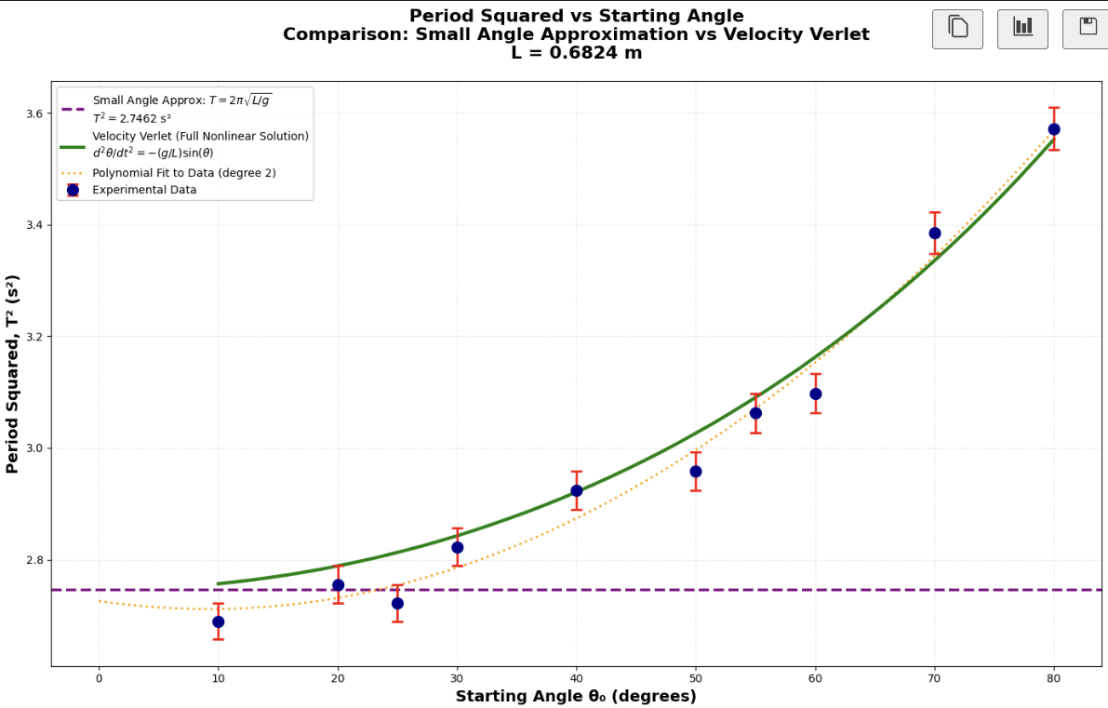
The small angle approximation had an RMS error of 0.11 seconds. The Velocity Verlet had an error of 0.02 seconds. This is a factor of about 6 which is massive. The mean absolute percentage error for the small angle approx. was 4.32% and the Velocity Verlet was 0.75%.

- The plot for the second experiment yielded this graph:
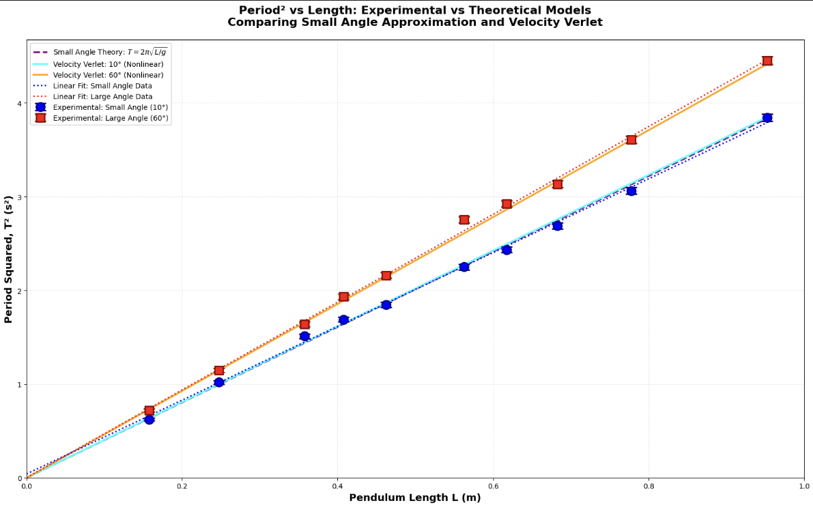
The small angle (10 degrees) period squared vs length graph using the small angle approx. yielded an RMS error of 0.016s. The velocity verlet for the small angle showed an RMS error of 0.016s.
The large angle (60 degrees) period squared vs length graph using the small angle approx. yielded an RMS error of 0.115s. The velocity verlet for the large angle showed an RMS error of 0.017s.
These are profound numbers due to their show that the small angle approximation is obviously not good at large angles.

- The plot for the calculation of the gravitational constant on earth yielded a graph like this: 